Add Airbnb base config to ESlint

1 – add ESlint plugin import support

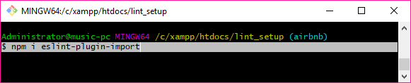

2 – install the Airbnb config-base files

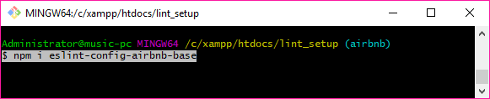

3 – run npm install to update ESlint config

